Polasaí agus Prótacail do Chuairteoirí
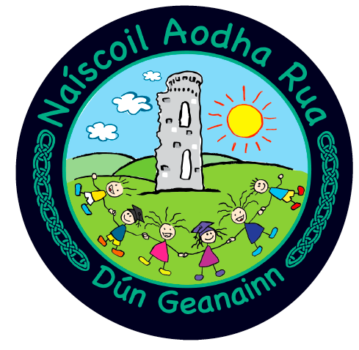
Policy and Protocol for Visitors

In Naíscoil Aodha Rua, we pride ourselves on the warm ‘Céad Míle Fáilte’ usually given to all visitors to our setting. However, as part of our Covid-19 risk assessment and in line with DE & PHA guidance, we now find ourselves in the position where visits to our school must be restricted, to reduce footfall, social interaction and possible spread of infection.

These Covid-19 Guidelines are in addition to our existing protocols for visitors, including policies in respect of Child Protection and Safeguarding.

This document must be read by ALL visitors to our school, prior to or on arrival. We ask for the support, understanding and full cooperation of our visitors in helping us minimise the risk of COVID-19 in our school.

Access Arrangements for External Visitors

All proposed visits from external visitors must be pre-arranged by phone or email and sufficient time given to allow for risk assessments to be carried out and safety measures put in place.

No un-announced ‘callers’ will be admitted to the school building.

In line with guidance from the Public Health Agency, the Department of Education and the Education Authority, we are limiting access to our school buildings to essential visitors only:

- Approved EA contractors (out of school hours where possible)
  - EA officers eg. RISE NI, Educational Psychology etc.
- EYS / Altram officer
- External service providers – for outdoor sessions where possible

All other requests for visits will be risk assessed by the Principal and all other alternative options, including telephone meetings / virtual video conferencing, will be considered.

Protocol for External Visitors
- Visitors will have their temperature taken on arrival at the school.
- Visitors will be asked to complete a Covid questionnaire and will be ‘signed in’ by the Naíscoil leader .
- Visitors will be asked to sanitise their hands on arrival and departure, to practice good respiratory hygiene and to wear a face-covering throughout their visit.
- Visits will be held in a well-ventilated room and meetings will be kept short and concise, with a duration of less than 15 mins, if possible. If a meeting runs takes more than 15 mins, it is advisable to take a ‘fresh air’ break outdoors before the meeting recommences.
- Guidance on social distancing (2m between adults) will be adhered to.
- Visitors will only be granted access to pre-agreed areas of the school.
- Visitors should inform the person they are meeting if they begin to feel unwell during the meeting, or if they display symptoms of Covid-19 / a positive test in the 48 hours after the meeting, to facilitate contract tracing.

Access Arrangements for Parents / Guardians

The cornerstone of our setting has always been the warm, working partnership that we cultivate with the parents / guardians of our pupils and although the pandemic has greatly reduced our ‘face to face’ interaction, we have put in place a range of alternative methods of communication, eg. text / whatsapp service, closed Facebook page, e-mail etc. to help maintain our positive working partnership.

In line with DE / PHA guidance, parents are asked not to enter the school buildings without prior appointment and to adhere to the arrangements in our Collection Policy, when dropping off / collecting children from school. All meetings with parents, unless in exceptional circumstances, will be carried out by phone or e-mail and guidance should be followed from our ‘Communication Policy’ if a parent / guardian needs to contact the school.

We recognise that in exceptional circumstances, parents may have a query or concern which they need to discuss in a ‘face to face’ meeting with a member of staff. The protocols, as described above for external visitors, will be followed in this scenario.

VISITORS SHOULD NOT ENTER OUR SCHOOL IF:

- you have tested positive for Covid-19
- you have symptoms of Covid-19 (listed below)

- a temperature/fever (above 37.8C)
- a new, continuous cough
- change in your sense of taste or smell.

- you have cold or flu symptoms.

- you have suffered from vomiting or diarrhoea within the last 48 hours.

- if you or anyone in your household is required to self-isolate in accordance with PHA guidelines

We apologise for not being able to give you our usual warm welcome, but we have a duty of care to protect our pupils, staff and their respective families from the spread of Covid-19. We also want to avoid any unnecessary class / school closures or periods of isolation due to Covid, so that face to face learning can continue un-interrupted. If you have any further questions, please contact the Naíscoil leader.

