As a parent, how can I raise a concern about a member of school staff
- Speak with the school Principal / Designated CP Teacher
- If the complaint is about the Principal, speak with the Designated teacher for CP, who will inform the Chair of the BOG immediately.
- Advice will be sought from EA on how to proceed & an investigation will commence.

How does the school respond to concerns of a Child Protection nature in respect of a member of staff?
- If the concern is against the Principal, the Designated CP officer will deal with it.
- If the concern is about a member of staff who is not the Principal, the principal will deal with the allegation.
- The Chair of the BOG will be informed immediately.
- A written record of the allegation will be made immediately.
- Advice will be sought from EA Child Protection team.
- If a referral is necessary, Social Services and / or PSNI will be informed.
- If a referral is not necessary, a staff disciplinary procedure will commence & a decision will be made regarding the possible suspension of the staff member.

CHILD PROTECTION ETHOS

We in Gaelscoil Aodha Rua have a responsibility for the pastoral care, general welfare, well-being and safety of the children in our care. All staff, both teaching and non-teaching, will be trained to be alert to the signs of possible abuse and will know the procedures to be followed in the event of an incident of a Child Protection nature. This document summarises the main actions which will be taken in the event of any incident of a Child Protection nature. We are also part of the ENCOMPASS scheme & will be informed by the PSNI of any incidents of domestic violence in homes.

PRINCIPLES OF CHILD PROTECTION POLICY

The general principles, which underpin our work in the area of Child Protection are those set out in the:
- UN Convention on the Rights of a Child
- NI Children’s Order of 1995.
- Safeguarding & Child Protection in Schools – DE 2024
- Co-operating to safeguard children & young people in NI – DHSSPSNI 2017
- SBNI Core Child Protection Policy & Procedures publications 2017.

OUR SCHOOL SAFEGUARDING TEAM

Designated Teacher for Child Protection:
Mrs Caitlín Anderson
Deputy Designated Teacher: Mr Eugene Mc Kenna & Mrs Laoise Uí Ghlacáin (Mrs Clíona Dolan is on maternity leave)
Principal: Mrs Móna Uí Dhochartaigh
Designated Governor for Child Protection:
Mrs Aisling Uí Choinn
Chair of BOG: Mr Tiarnán O Neill

(Photos on display on Child Protection notice-board & contact details available from school office.)
RIGHTS OF THE CHILD
All children have the right to feel safe, secure, loved and valued, both at home and in school. They also have the right to be listened to and to be taken seriously.

TYPES OF CHILD ABUSE
Child Abuse occurs when a child is neglected, harmed or not provided with proper care. Children may be abused in many settings, by those known to them, or more rarely by a stranger. There are different types of child abuse and a child may suffer from more than one of them. These include:
- Physical Abuse
- Emotional Abuse
- Neglect
- Sexual Abuse / Exploitation / Female Genital Mutilation
- Domestic Violence (passive / active)

ROLE OF STAFF
All staff in our school have a responsibility to be vigilant and to watch for signs of possible abuse:
- Unexplained marks or bruises
- Changes in child’s behaviour / interactions
- Change in appearance (weight loss, personal hygiene)
- Hunger, tiredness, poor hygiene, frequent absences
- Signs of self-harm / Inappropriate sexual behaviour

ROLE OF PARENTS
Parents can play their part in creating a positive Child Protection ethos in our school by:
- Familiarising themselves with school policies
- Explaining / informing the school of all absences
- Informing school of changes in collection arrangements
- Keeping school informed of any changes in family circumstances / contact details.
- Raising any concerns they have about their own / another child with the school.
- Encouraging their child to trust and talk to school staff.

LINKS TO OTHER SCHOOL POLICIES
- Collection Policy
- Intimate Care Policy
- Permission Policy
- Administration of Medicine
- Safe use of Internet / E Safety
- Addressing Bullying Policy
- Communication with Parents / Guardians policy
- Complaints policy

As a parent, how can I raise a concern about a Child Protection issue regarding my own / another child?
- Speak with the child’s class teacher.
- Speak with Designated / Deputy Designated Child Protection Officers or with the Principal.
- Speak / write to Chair of Board of Governors (contact details available in school office – 028 877 53762)
- Ring Gateway Team on 028 37 567 100
- Ring PSNI Central Referral Unit on 101

How does the school respond to concerns
of a Child Protection nature?

- As an Encompass school, we respond to concerns raised by the PSNI in respect of children who may be at risk of harm.
- Staff member will make notes of the disclosure / observations that have concerned them or which have been made by a third party.
- DiscIosure / Observations will be discussed with the Designated Child Protection Teacher and Principal.
- Advice will be sought from Education Authority CP service.

Gaelscoil Aodha Rua

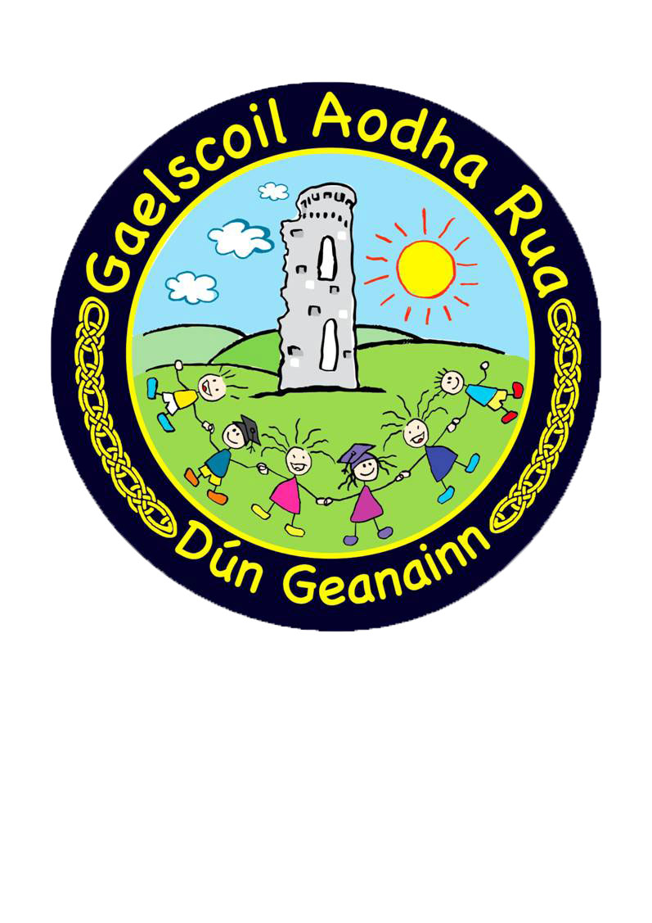

Child Protection Summary
2025-26

Uasdátaithe i Mí na Samhna 2025
Updated in Nov 2025

- If a referral is necessary, a call will be made to Gateway Team (Social Services)
- If the suspected abuser is the child’s parent, Social Services / PSNI will contact them.
- If the suspected abuser is not the child’s parent, the school will inform the parent of the incident.

CHILD PROTECTION & SAFEGUARDING POLICY & PROCEDURES

Our full policy on Child Protection and all information pertaining to Child Protection / Safeguarding, including guidance on how to raise a concern, is on display on the ‘Safeguarding’ noticeboard outside the office.
This Child Protection summary, the full Child Protection & Safeguarding policy and a suite of other school policies are also available on our school website:
www.gaelscoilaodharua.com

If you would like to request a copy of our Child Protection & Safeguarding policy, or any of our other school policies & procedures, please call the school office.

USEFUL PHONE NUMBERS
Gaelscoil Aodha Rua: 028 877 53762
Gateway Team (Armagh) 028 37 567 100
PSNI Central Referral Unit 101

