An Éide Scoile / Our School Uniform
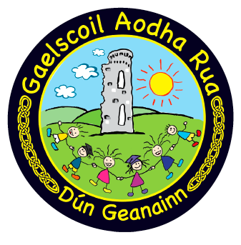

The uniform of Gaelscoil Aodha Rua consists of:

- Navy jumper with school crest;
- Golden yellow polo-shirt with collar (no crest)
- Navy school trousers (not jogging bottoms / skinnys)
- Navy skirt / pinafore
- Black shoes
- Navy tights / navy or white socks

Children can wear their sports gear on days when we have PE and this consists of:
- navy polo shirt
- navy shorts / navy jogging bottoms / skinnys

The school sports polo-shirt and / or jersey will be available to purchase from the school in September

During good weather navy shorts / gingham dresses can also be worn.

Gaelscoil Aodha Rua Crest
Our school crest is symbolic of our school ethos and portrays the faces of happy children who are all different, all individual and motivated for learning. It portrays the important cultural link that we have with our ancestors in the time of the great O Néill and the bright colours depict the bright future which lies ahead of our boys and girls.

Guidance for Parents
This year, we will be making a concerted effort to encourage our pupils to wear their school uniform with pride and we will be reminding them that they are ambassadors for our school when out in public in their uniform.

We encourage parents to ensure that children are dressed in full school uniform, yet we wish to ensure that we do not place excessive financial demands on parents when purchasing uniforms for their children.

As requested in our end of year letter that accompanied the school reports, we respectfully ask that all parents purchase our school jumper & golden yellow polo short from Kelly’s Drapery, so that all children are wearing the same colour of t-shirt.

Navy school trousers, skirts & pinafores can be purchased in a shop of your choosing. We ask that parents do not purchase a school coat, as they get easily misled at the end of the school day, when they are all exactly the same.

We appreciate your support on this issue and look forward to welcoming you all back to school in September.

